Week 5
Q1. Write a C++ program to enter elements in the array and display the array elements.
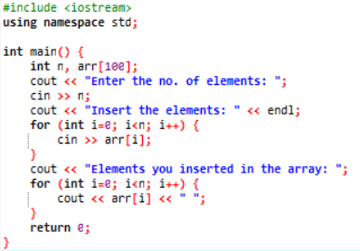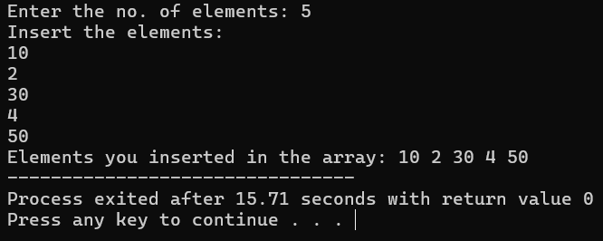
Q2. Write a C++ program to find the sum of all the array elements.
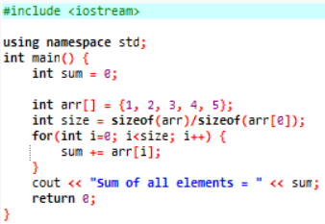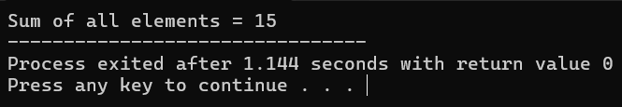
Q3. Write a C++ program to find the length of the array.
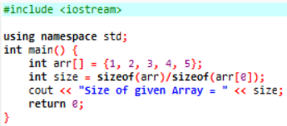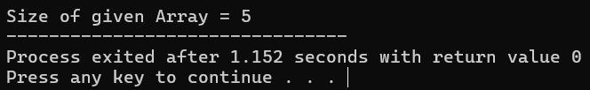
Q4. Write a C++ program to find the second-largest integer in a list of integers.
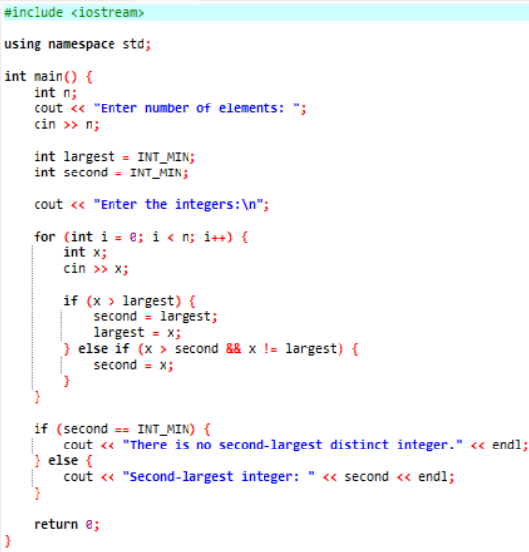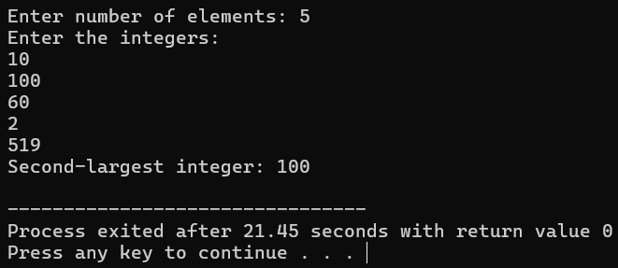
Q5. Write a C++ Program to reverse the position of the array element (Hint: First element to the last element.)
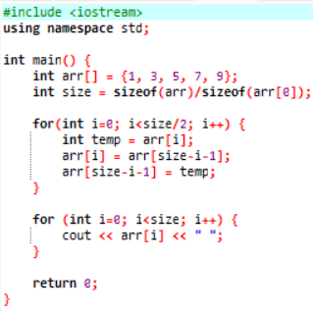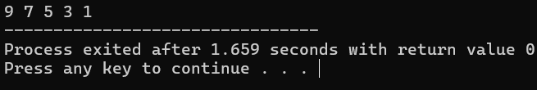
Q6. Write a C++ program to perform the following: a. Addition of two matrices b. Multiplication of two matrices
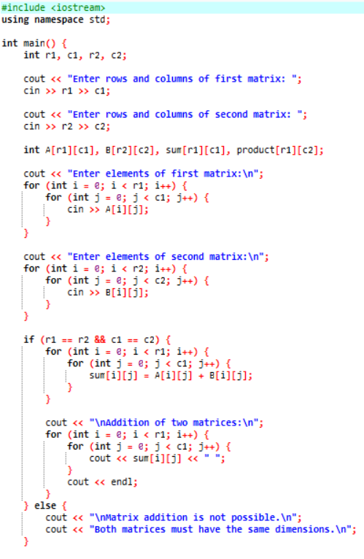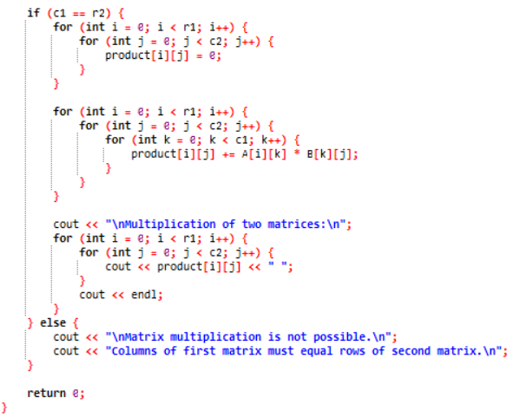
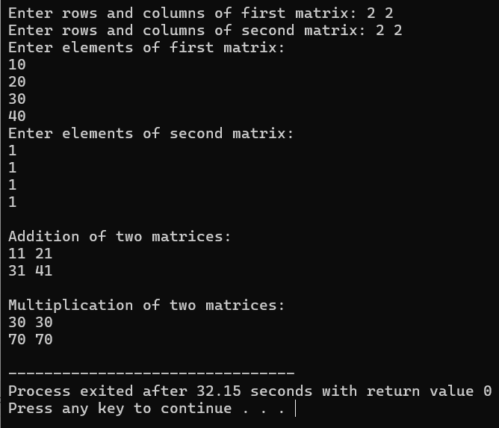
Q7. Write a C++ program to count and display positive, negative, odd, and even numbers in an array.
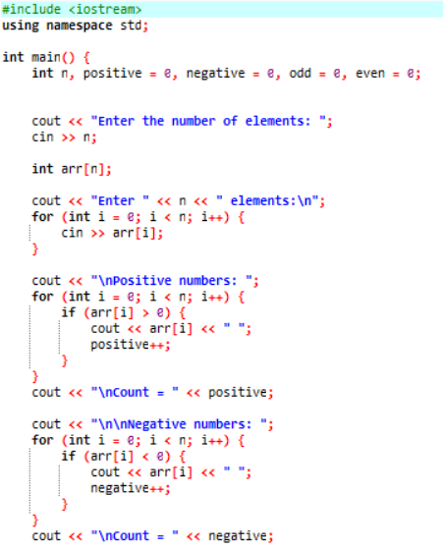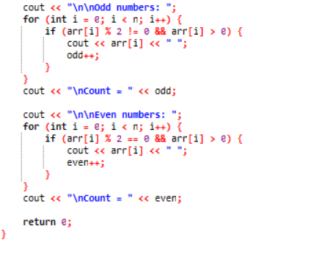
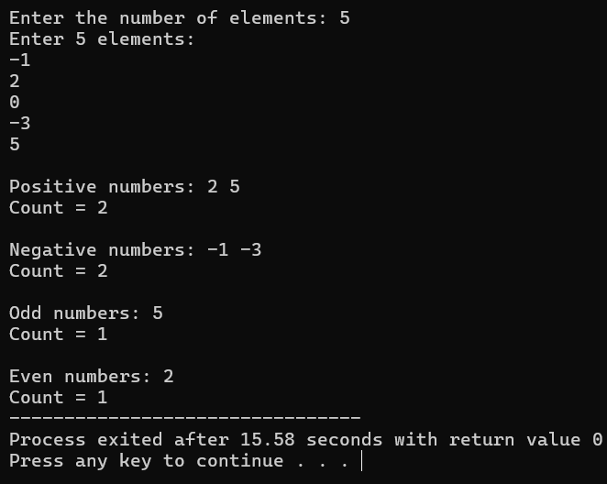
Q8. Write a C++ program to merge two sorted arrays into another array in sorted order.
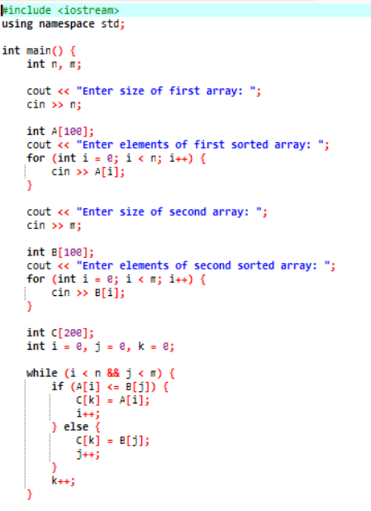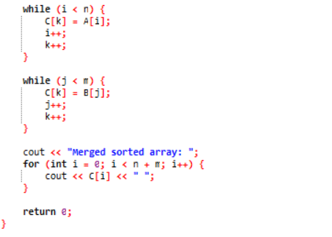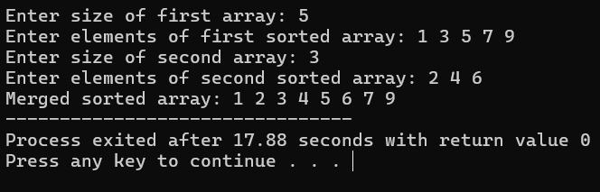
Q9. Write a C++ program to find the frequency of a particular number in a list of integers.
